SQL Analysis Report
Financial Fraud Detection Using Credit Card Transactions

1. Data Loading
Objective
To create a structured database for storing and analyzing credit card transaction data using MySQL.
Analysis
A database schema named Finance was created to store the project datasets. Two tables, cc_data and location_data, were created using appropriate data types for numerical, categorical, geographical, and date-related attributes. The datasets were successfully imported into MySQL, ensuring data integrity for subsequent SQL analysis.
Outcome
The structured database enabled efficient querying, aggregation, and analysis of transaction records throughout the project.

2. Total Number of Transactions
Objective
To determine the total number of transactions available in the dataset.
Analysis
A SQL query using the COUNT() function was executed to calculate the total number of transaction records stored in the cc_data table.
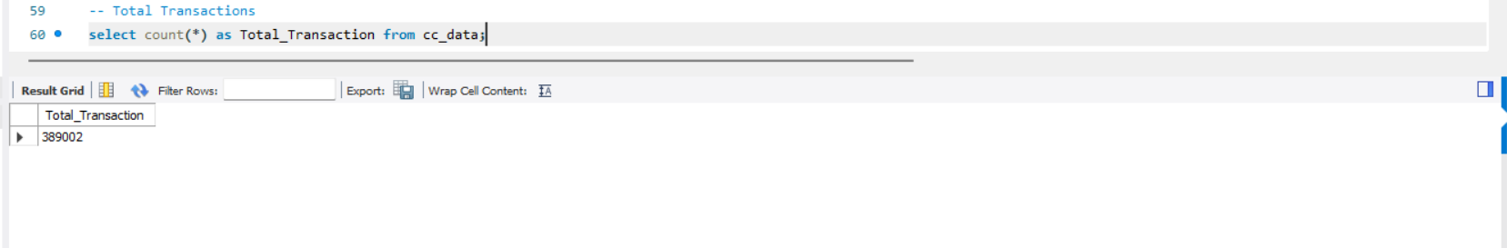
Result
The dataset contains 389,002 credit card transactions, providing a substantial volume of data for fraud analysis.

3. Top 10 Most Frequent Merchants
Objective
To identify merchants with the highest transaction frequency.
Analysis
The transaction records were grouped by merchant name using the GROUP BY clause, and the results were sorted in descending order based on transaction count.
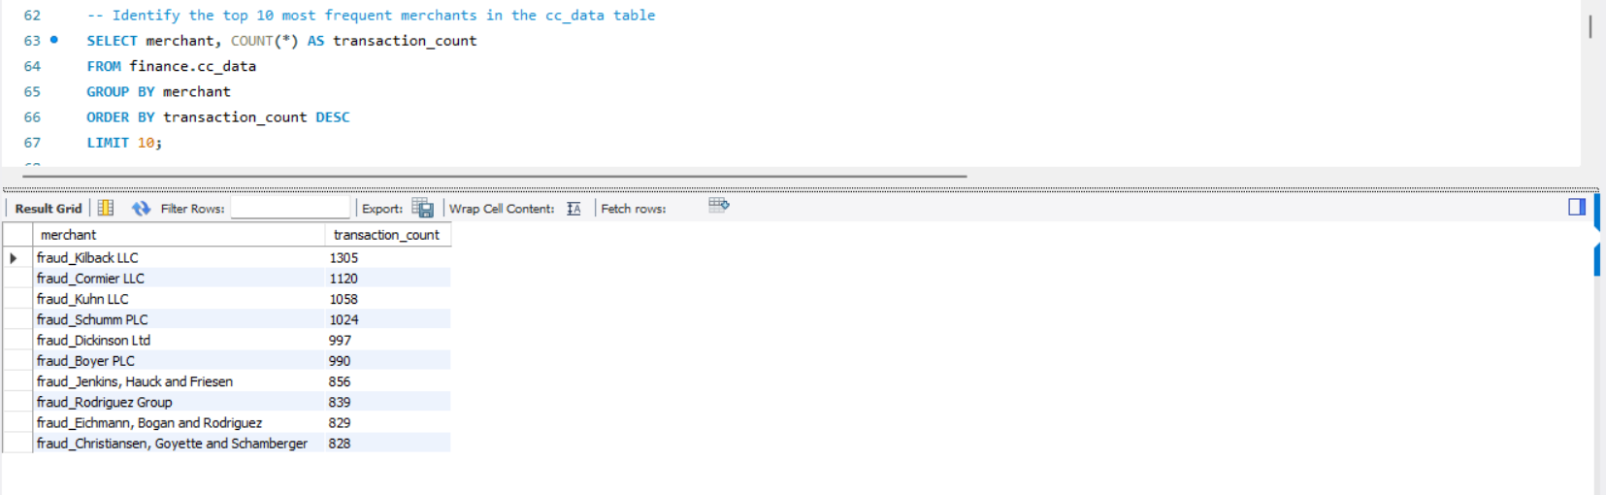
Key Findings
The analysis identified the ten merchants responsible for the highest number of transactions. These merchants represent the most frequently used businesses within the dataset and may require continuous monitoring due to their high transaction volume.

4. Average Transaction Amount by Category
Objective
To compare average transaction amounts across different transaction categories.
Analysis
The AVG() aggregation function was applied after grouping transactions by category.

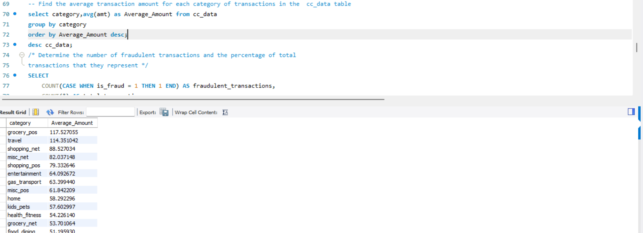
Key Findings
The average transaction amount varies across categories, indicating differences in customer spending behavior. Some categories consistently involve larger purchases than others, reflecting distinct consumer purchasing patterns.

5. Fraudulent Transactions and Fraud Percentage
Objective
To determine the total number of fraudulent transactions and calculate the fraud rate.
Analysis
SQL aggregation functions were used to count fraudulent transactions (is_fraud = 1) and calculate their percentage relative to the total number of transactions.
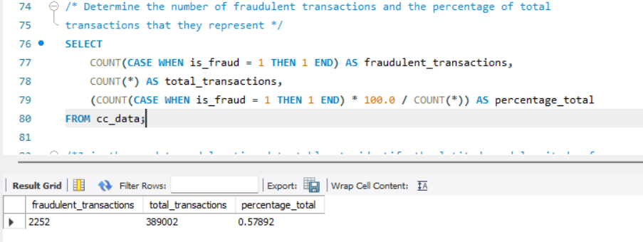

Key Findings
The dataset contains a relatively small proportion of fraudulent transactions compared to legitimate transactions. This confirms that the dataset is highly imbalanced, which is a common characteristic of fraud detection problems and presents additional challenges for predictive modeling.

6. Joining Transaction and Location Data
Objective
To combine transaction information with geographical coordinates.
Analysis
An INNER JOIN was performed between the cc_data and location_data tables using the common cc_num field to retrieve latitude and longitude information for each transaction.
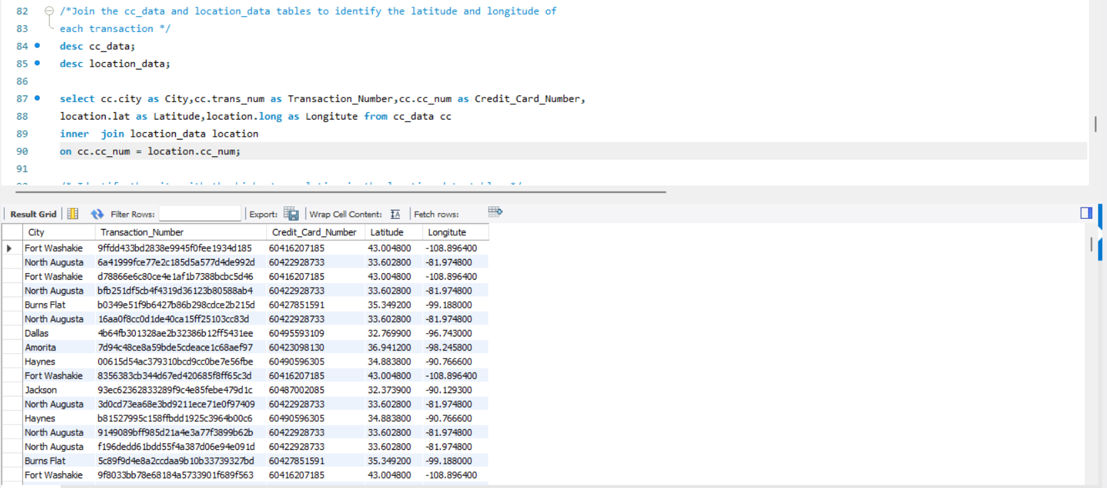
Key Findings
The join operation successfully enriched the transaction dataset with geographical coordinates, enabling future spatial analysis and map-based visualizations in Tableau.

7. City with the Highest Population
Objective
To identify the city with the largest population represented in the dataset.
Analysis
The records were sorted based on the city_pop column in descending order to identify the city with the highest population.
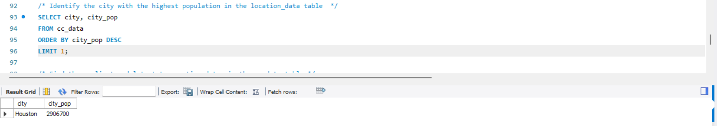

Key Findings
The analysis identified the city with the maximum recorded population, providing insight into the largest metropolitan area represented within the transaction data.

8. Earliest and Latest Transaction Dates
Objective
To determine the time period covered by the dataset.
Analysis
The MIN() and MAX() functions were applied to the transaction date column to retrieve the earliest and latest transaction dates.
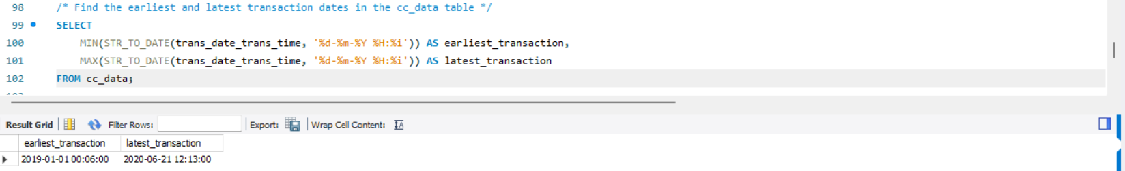
Key Findings
The dataset spans a clearly defined time period, allowing temporal analysis of customer transaction behavior and fraud trends.

9. Total Amount Spent
Objective
To calculate the overall transaction value processed within the dataset.
Analysis
The SUM() function was applied to the transaction amount (amt) column.
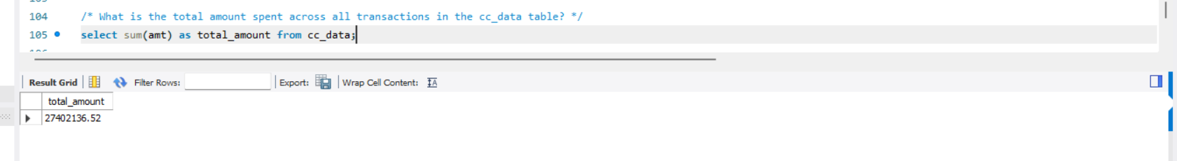
Key Findings
The total transaction amount represents the complete financial volume processed within the dataset and provides an overall measure of customer spending activity.

10. Transactions by Category
Objective
To determine transaction frequency across different categories.
Analysis
Transaction records were grouped by category and counted using the COUNT() function.
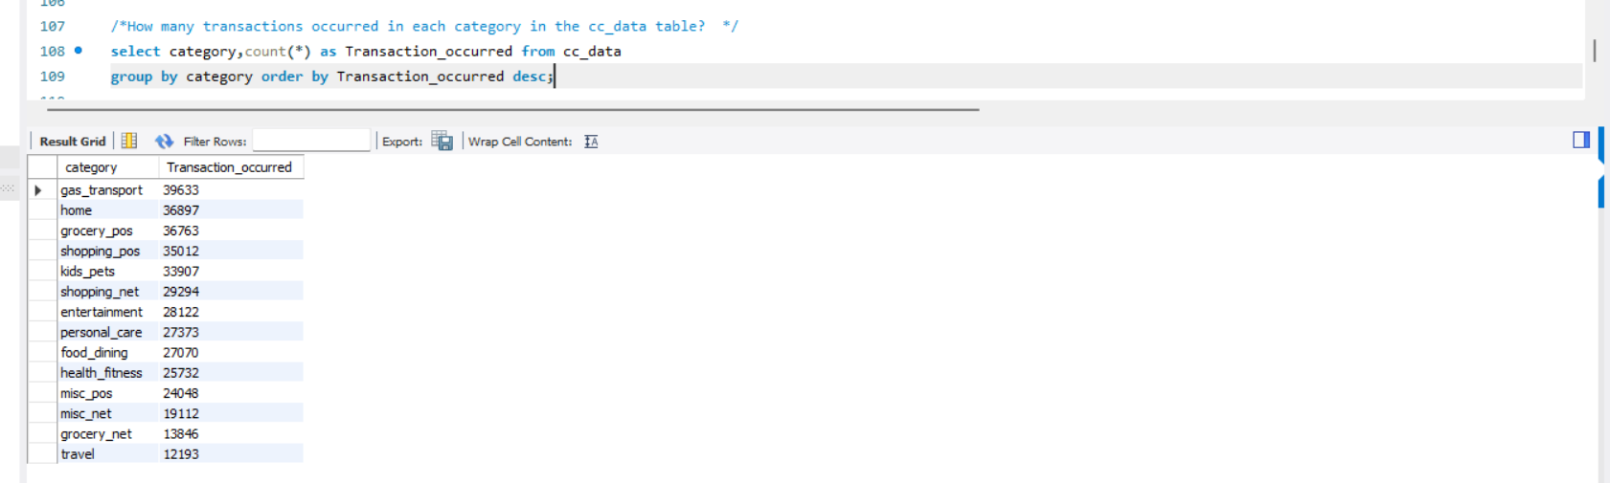
Key Findings
Certain categories recorded significantly higher transaction volumes, indicating greater customer activity within those spending categories.

11. Average Transaction Amount by Gender
Objective
To compare spending behavior between male and female customers.
Analysis
The AVG() function was used after grouping transactions by gender.
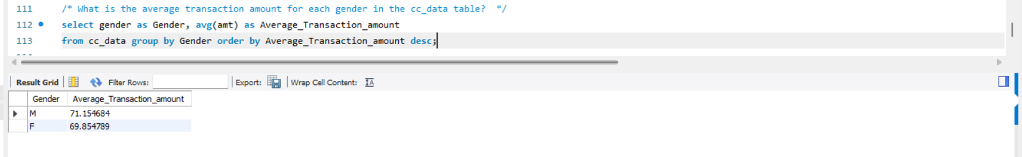
Key Findings
The comparison provides insight into spending patterns across genders and highlights any noticeable differences in average transaction values.

12. Day of the Week with Highest Average Transaction Amount
Objective
To determine whether transaction amounts vary by day of the week.
Analysis
Transaction dates were converted into weekday names using MySQL date functions, followed by calculation of average transaction amounts for each day.
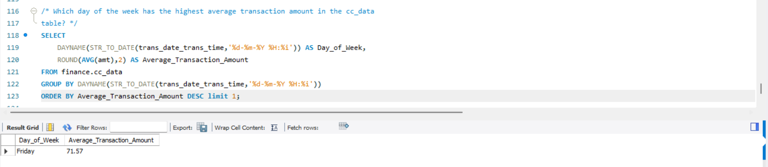
Key Findings
The analysis identified the weekday associated with the highest average transaction value, offering valuable insight into customer purchasing behavior across different days.

Overall SQL Conclusion
The SQL analysis successfully transformed raw transaction data into meaningful business insights through filtering, aggregation, grouping, and table joins. The queries identified transaction volume, customer spending patterns, fraud distribution, merchant activity, geographical information, and temporal trends. Furthermore, SQL enabled efficient integration of transaction and location datasets, preparing the data for advanced analysis and visualization. These findings serve as an important foundation for exploratory data analysis in Python and interactive dashboard development in Tableau.

